International Health Care
Refugee Crisis
Ways the refugee crisis is an international crisis and my views on how various nations have responded.
Refugee crisis has been in the rise in the past decades. This has been fueled mostly by politics, economics and many other upheavals such as war that have been on the rise. Refugee crisis is an international crisis because it almost affects each other country that is experiencing the upheavals of war and politics among others. Many countries that neighbor countries with upheavals have been a destination for many. For example, Greece is the main transit for refugees heading to Germany. Turkey hosts refugees from the Syrian conflict. Other nations across the world that have hosted refugees include; Canada, Germany, France, Kenya, Jordan, Armenia, and Saudi Arabia. Many countries have responded positively. They have hosted these refugees, provided them with shelter, food and housing. Some of them have even become citizens of those countries and they can access government services and employments in the host countries (Green & Duncan, 22).
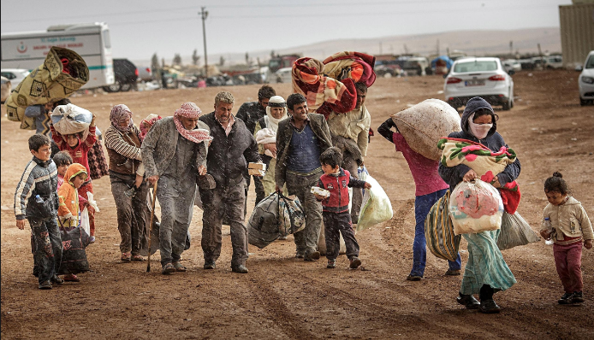
The healthcare, gender, political, or social implications of the content of the photo.
From the photo it is evident that the refugees go through harsh climatic conditions as they traverse to look for places to hide and stay far from war. Their health deteriorates because of poor feeding and dust. Mostly the women and children are mostly affected in times of war.

The city of Bowling Green in Kentucky is among the USA cities that have welcomed refugees. Thoughts how citizens and refugees could help each other
I believe that refugees can share what they have with them it creates an environment for them to thrive. When they stay united, they are most likely able to face the challenges together and conquer them. Citizens should live with the refugees as brothers and make to them any contributions that they need. Refugees have skills and knowledge that can be tapped and used in developing the host country (UNESCO, 14).

Works Cited
Green, Duncan. From Poverty to Power: How Active Citizens and Effective States Can Change the World. Oxford: Oxfam International, 2010. Print.
The Hidden Crisis: Armed Conflict and Education. Paris: UNESCO, 2011. Print.

